Description:

We designed and created a database for the Oregon State Greek Life. The database will provide a pool of information of members in each fraternity, parties, and positions within each house. In OSU Greek Life, each member is associated with one fraternity; some members are able to be elected into a position, while some are not affiliated with any positions. This database also keeps track of attendance at parties, whether or not a member brought a guest, and if a member is sober and responsible for others in attendance.

The FRATERNITY entity has five attributes, with fName and Chapter being the primary keys. The other attributes are # of Members, Colors, and Address.

The MEMBER entity has seven attributes, with mName and sID being the primary keys. The MEMBER table contains two foreign keys in our relation table, fName and Chapter, in order to connect each member to their specific fraternity. The other attributes are Age and Year in the House, and Major.

The POSITION entity is denoted by the primary key pName and has Rank, Date Elected, and Description as its attributes. The foreign key sID is used to associate each member with a position.

The PARTY entity has partyName and Location (as in, which fraternity is hosting) as primary keys and has Date, Time, Theme, Additional Hosting Houses as its attributes. The two foreign keys in PARTY are fName and Chapter of the hosting house.

The ATTENDANCE entity has sID as its primary key. partyName and Location are its foreign keys. Its other attributes consist of whether a member is sober or not (denoted by “Sober Brother”) and whether or not a member invited guests or a date.

Relations:

-MEMBER belongs to exactly one FRATERNITY yet a FRATERNITY has mandatory many members.
-A MEMBER can hold optional many POSITIONS within the house but each POSITION is
associated with exactly one member.
-Each FRATERNITY has optional many PARTIES and each PARTY could be thrown by one or many PARTIES.
-A MEMBER can attend many PARTIES, while a PARTY may be attended by zero or many MEMBERS. A PARTY can still exist even if no MEMBER is in attendance (although it would be sad).

Functionality:

The user can print a list of every member in the fraternity. If desired, the user is able to select a member by their sID and get all the information on specified member. This database can hold information on parties, which the user could access, either to add an event or check on planned events. The user will also be able to see who was at a party and whether or not a specific member was sober or not. Position descriptions and ranks are available to the user, as well as which members filled a specific position. The database keeps organized information about fraternities and members.

Questions:
- In the FRATERNITY table, how do we auto-increment number of members in SQL when another member enrolls in that fraternity?
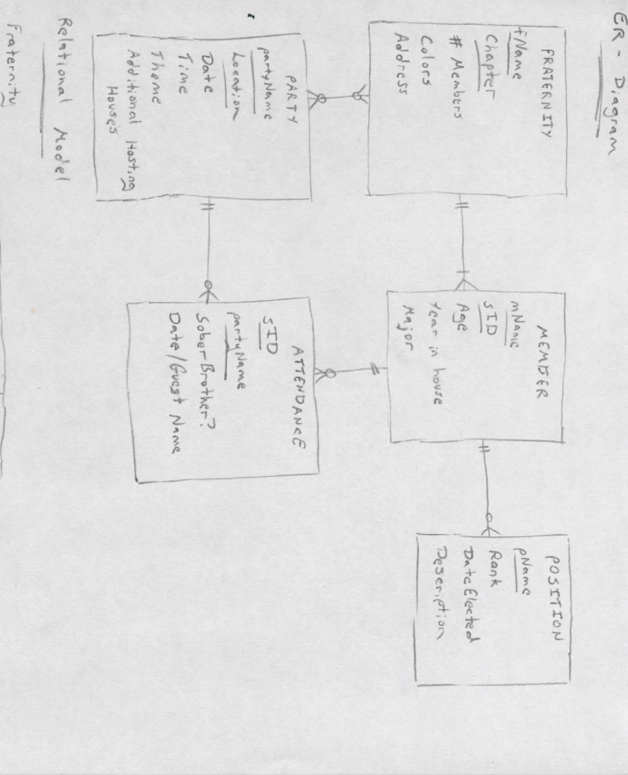
- Would the FRATERNITY and MEMBER tables need an associative ENROLLMENT table to keep track of which fraternity each member belongs to or is the fraternity ID (fName and Chapter) okay in the member section of our table?

ER – Diagram:

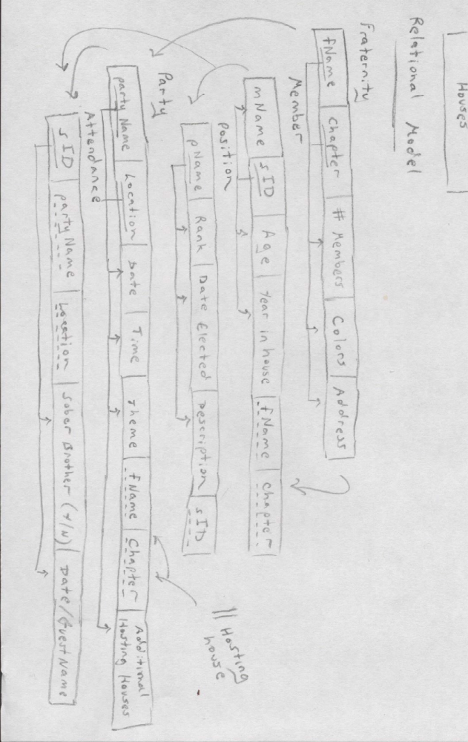
Relational Model:

